Query all columns (attributes) for every row in the CITY table.

Input Format

The CITY table is described as follows:

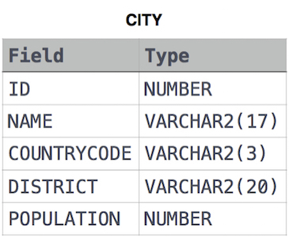

Solution:

SELECT \*

FROM CITY